Tug-Of-War Rules
Your squad will be scheduled to compete in tournament brackets. You’ll be able to download the tournament schedule from SportsFest.com the week
Single – ELIMINATION – Tournament, times TBD
Team Member Requirements – 5 players; 3 Men & 2 Women

Match time allotted: 45 seconds Win your matches by:

- Tug the opposing team’s pennant over the mark!

- Maintain the advantage at the 45 second time limit.

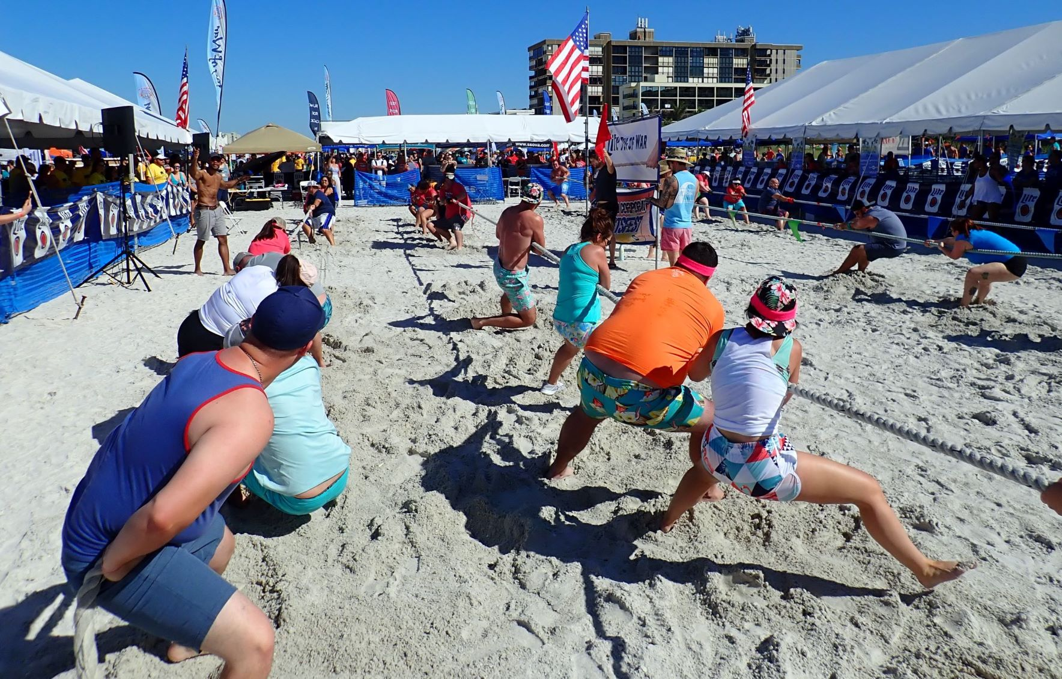
of the event. Know your bracket start time and check into the On-Deck Area 15 minutes early to avoid disqualification for not entering your designated court when your Team is called. If you’re scheduled in the 1st Session of Tug, your Volleyball Team will likely be scheduled in the 2nd VB Session. If the word BYE appears as your opponent, this means you automatically advance to the 2nd Round without having to face an opponent. This happens when there are too few teams to fill all the spaces in the 1st Round.

The Winner will be the team that pulls the opposing team’s rope marker over the center line or has the
advantage at the end of the time limit. In the unlikely case of a draw, the match will continue until one team gains the advantage.

Wear gloves for the best grip of the rope and to avoid abrasions. Competitors who wish to avoid arm and body abrasions should wear T-shirts and long sleeves.

Rules for SPORSFEST TUG A WAR:
- Four Tug Ropes (Black, Red, Green and Blue) will be used to coordinate the tournament.
- Two yellow markers will be attached to each rope, each 5 ft from the center color-coded pennant. These are the markers that will be used to determine winning teams.
- Do NOT tie rope around arm or body under any circumstance.
- There is no weight limit for team members.
- NO SITTING DOWN IN THE SAND allowed.
- Officials will give the Start Signal by raising a flag after soliciting a verbal confirmation of “Ready” from both team coaches.
- Win by pulling opposing Team’s Pennant over mark or maintain the pennant advantage at the 45 second time limit.
- If the teams are tied at the 45 the color-coded flag will remain in the middle (straight up) and teams will be told to “keep pulling” into overtime. The first team to gain a clear advantage will be the winner. The “Flag Official” will bring down the flag on the side of the team that won or has the advantage
- If you are the winner of your tug, you proceed to the holding area to await your next tug. Tugs will be scheduled approximately 10 to 15 minutes apart.

Grounds for Disqualification:
- If any member of your team grasps the rope in front of the marker, just in front of your lead puller.
- If any member of your team sits down in the sand and does not make an effort to stand up again.
- If the Coach or Mascot of your team physically assists any puller or touches the rope

