Beach Dodgeball Rules
Tournament/Scheduling Explanation:
Single – ELIMINATION – Tournament, times TBD
Team Member Requirements - 3 Men & 3 Women
You can play with less and women can play in place of men.
Subs are allowed in each new match you survive.

Win your matches by:

- “Terminate” all the competition within the allotted match time.

- Hold an advantage of active players at the end of 5 min. regulation.

- If tied, Sudden-Death Overtime will apply!

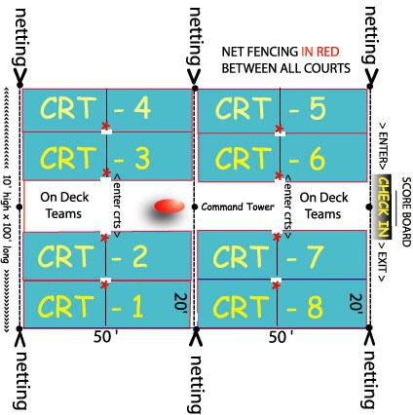

Your squad will be scheduled to compete in one of our four tournament brackets. You’ll be able to download the tournament schedule from SportsFest.com the week of the event. Know your bracket start time and check into the On-Deck Area 15 minutes early to avoid disqualification for not entering your designated court when your 16 Team Heat is called. All 8-Courts will begin play at the same time and end in 5 minutes or less if elimination of the opposing team is achieved. If sudden death overtime is needed, it will begin between the remaining players immediately! If you win your match, STAY In the “On Deck Area”, you will advance to the next round and compete within 10 minutes or immediately if you continue winning over the next three rounds. If your team is not TERMINATED before you reach the Semi Finals, you will advance to the Surviving Sixteen Single Elimination Championship Round. In this round your team will need to terminate four more lethal competitors to be declared the BEACH DODGEBALL CHAMPIONS!

Rules for SPORTSFEST DodgeBall:
- To start the game each team has 2 dodgeballs
strategically placed 8’ from the center line of the court and 1 more ball 4’ from the center line.
- If a player is hit by a “fly ball”, before it hits the sand and after being thrown by a player on the opposing team that player is out.
- If a player catches a “fly ball”, the thrower is out AND the other team returns an eliminated player to their team. Players come back into the game in the order which they were eliminated.
- A player who is hit in the head (if they did not duck) is not out. The thrower is out. If the player hit in the head did duck, no consequence.
- A ball deflected by a held ball, whether caught or not, does not result in player elimination.
- A ball rebounding off a “catch” attempt may be caught before touching the sand (nothing else) by any in bounds player on the “hit” player’s team.
Result: the thrower is out.
Out-of-Bounds: (Defined as: Our fences to the right and left and netting behind) Catching a ball out-of- bounds does not count. If a ball is deflected off one player and s/he or a teammate catches it out-or- bounds, the first player is still out because the catch does not count.
- A ball rebounding off a fence, net backstop, pole, etc. will not eliminate a player.

AREA OF ELIMINATED PLAYERS: a) Eliminated
players on each court will form lines on the North side of the court next to the fence in the center of the court. Keep in order of elimination with the first person standing by the center line on the fence sideline. Re-enter on a “caught” ball in same order eliminated. b) The Officials will be in the center of the court on the South side of the court.
- Eliminated players MAY NOT throw a ball back to their team; they may not throw a ball at the other team or hold onto a ball.
- Any balls going into the other court should be returned (note color of dodgeballs on your court).

