BOTE Beach Challenge Rules
Tournament/Scheduling Explanation:
Your paddleboard relay squad will be scheduled to race in one of four predetermined surf sessions. Once checked in and registered, your squad will move into the “Stand-By” and then “On-Deck” areas. Officials will organize 8 teams per heat on a first come, first serve basis. The winning team from each heat will advance to the finals.
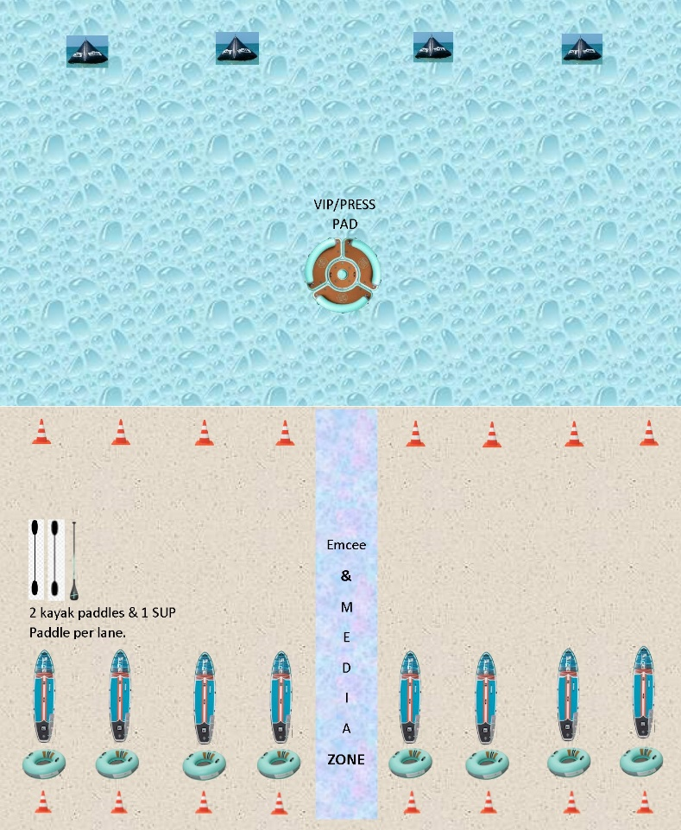
- There are 8 teams competing in each heat and the team with the fastest time in each heat will move onto the Championship Round in the afternoon.
- Four Guys and three Gals make up a team. Women can take the place of men, but not vice-versa.
- Starting with a gal in the tube, four guys will race 40 yards down to the surf, around a cone and return to the start where they will swap gal #1 for gal #2 and take a second lap.
- Upon their return, gal #3 and one of the four guys will pick up their inflatable BOTE SUP and their choice of double-bladed kayak paddles, a single blade SUP paddle or none.
- Together they will race down to the surf, paddle out 30 yards and round the closest BOTE buoy, then return to the beach and race back to the start with their SUP and paddles to finish the race.
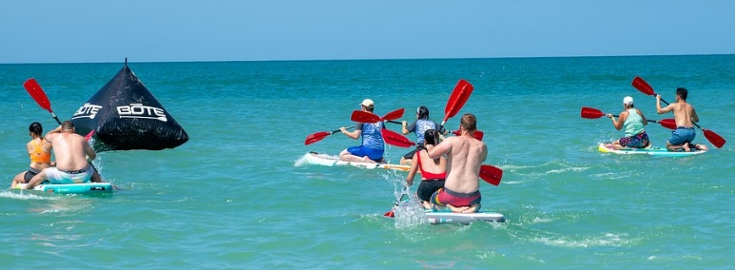

Rules for the BOTE Beach Challenge:
- Gal must be in the tube in order to advance the tube.
- SUP racers must start their leg of the race together and must both cross the finish line with their SUP and paddles used to complete the race.
- SUP racers must board their SUP upon entering the surf.
- Not going around a required course cone will result in a disqualification. This will be a Lane officials judgement call.

